Home assignment:
Integrate the Jira with this existing codebase
Activity: Integrate the AI Agent with Jira by adding a "Connect Jira" feature that allows users to establish a connection using their Jira Base URL, Email ID, and Jira API Token. Once the connection is successfully established, retrieve and populate the available Jira user stories within the application. Ensure the implementation follows the existing project architecture, UI design, and coding standards while maintaining compatibility with the current functionality.

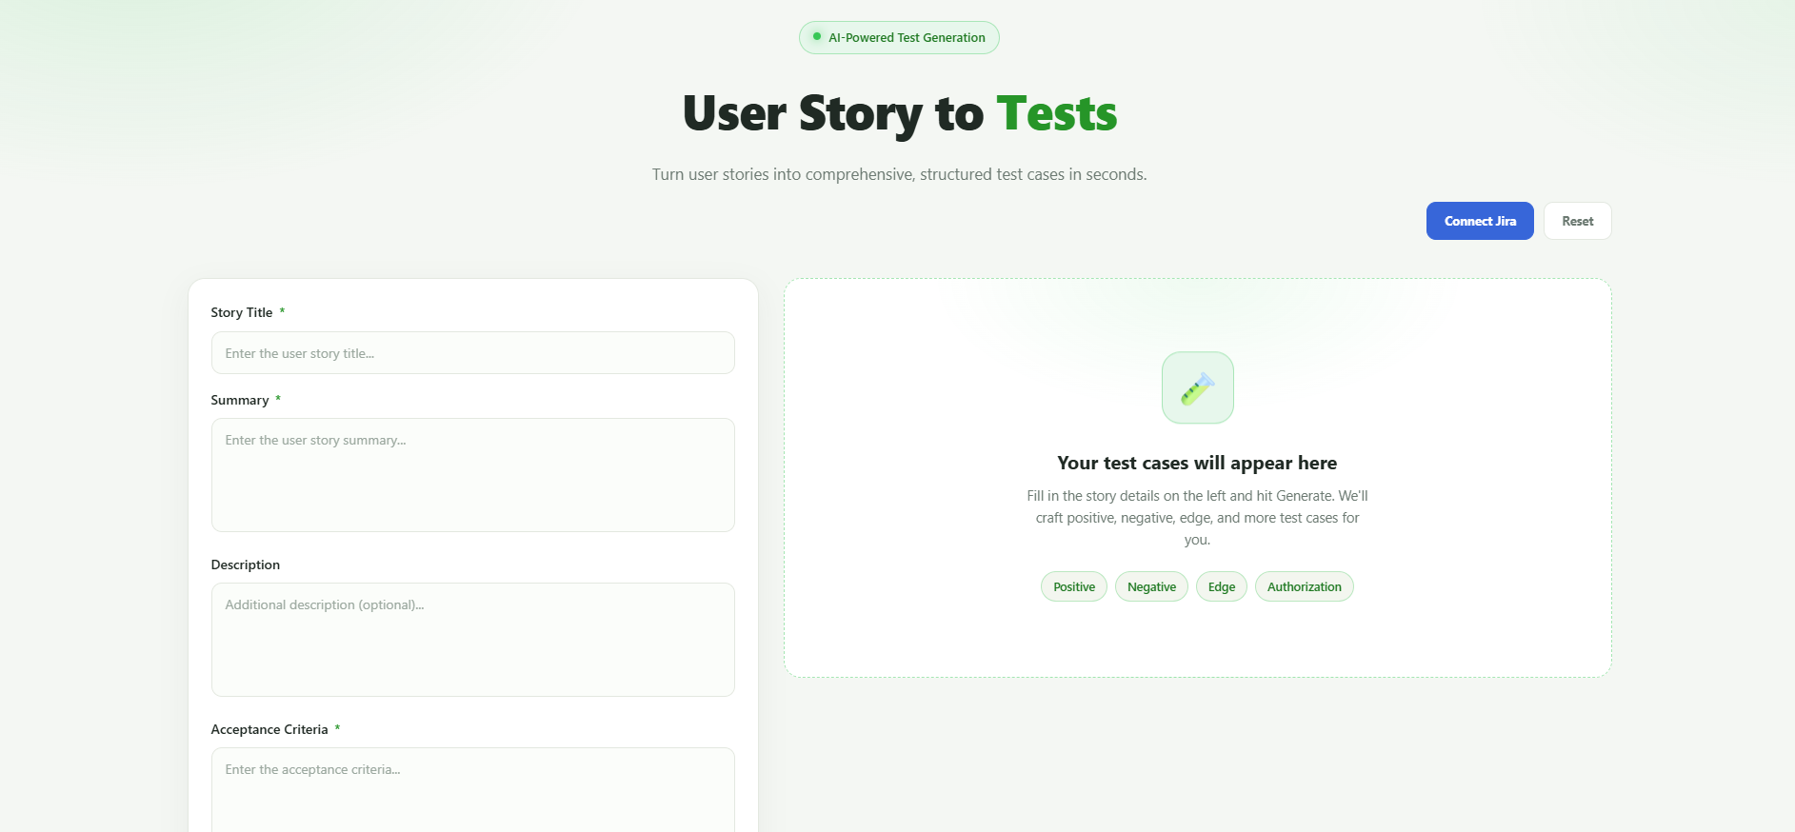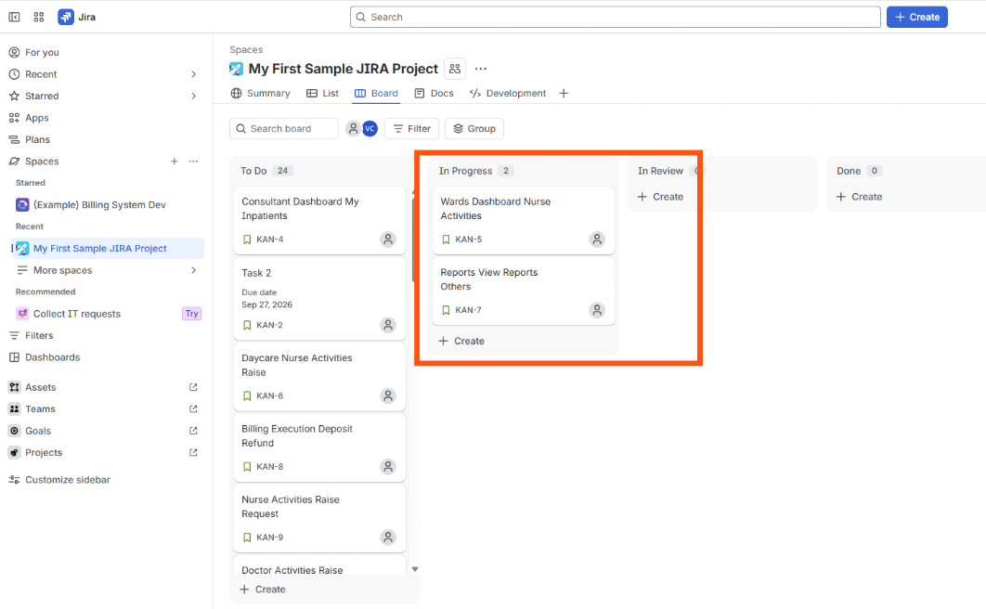
When I click on Connect Jira
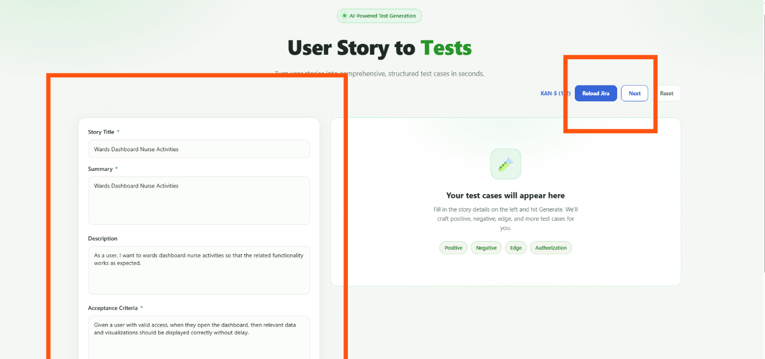
When click on Next then Next story populated
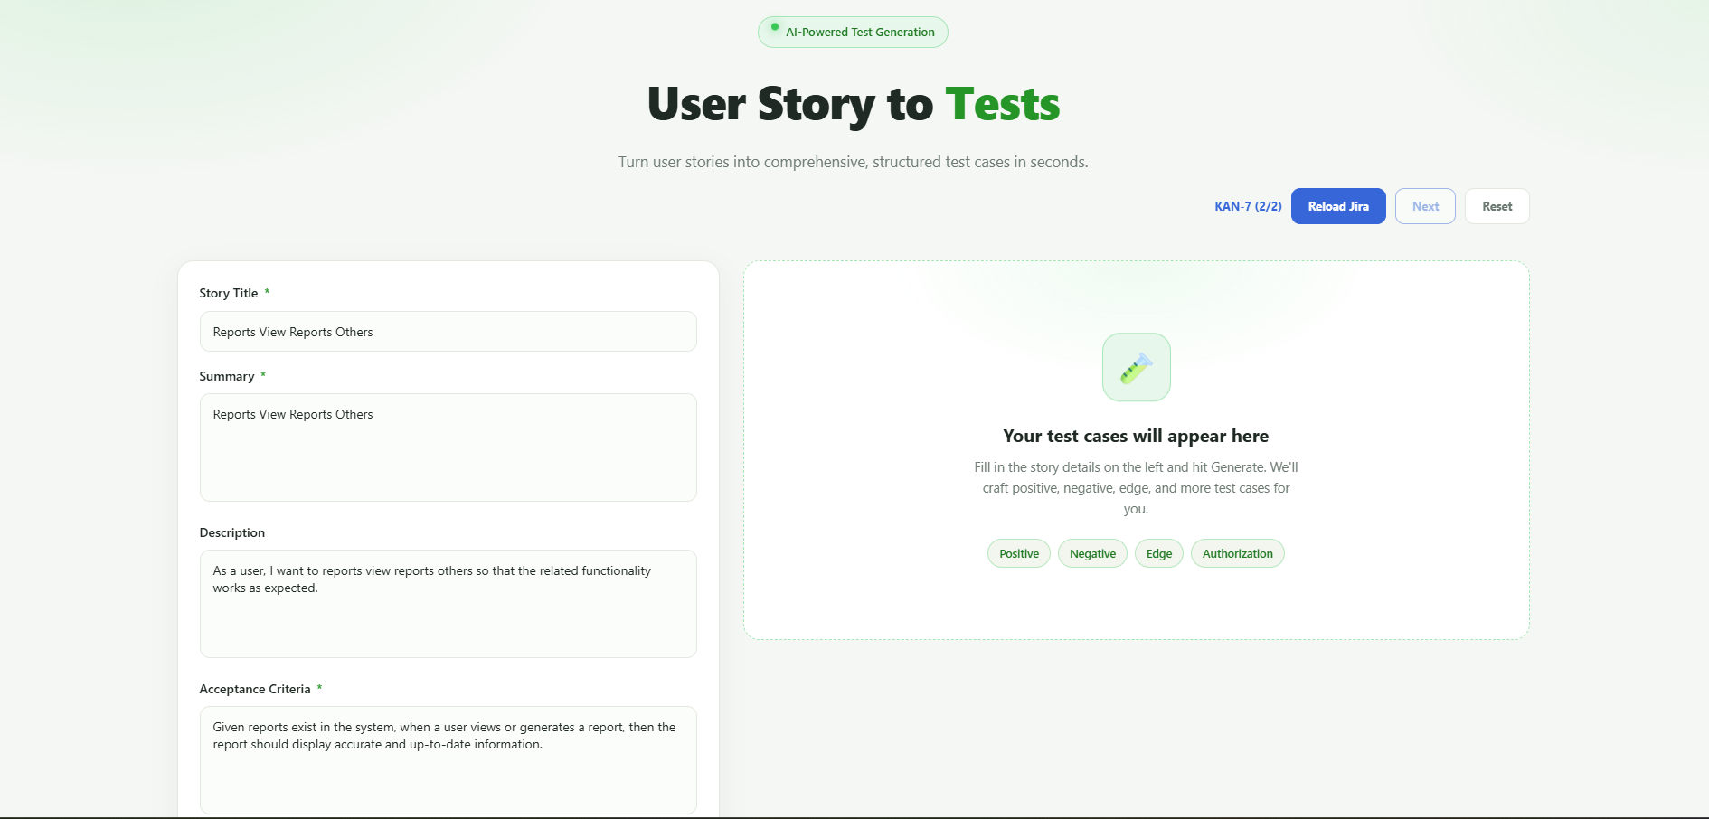

Assignment 2 :Add additional values on the browser extension UI

New Language JavaScript is added to Supported Language and code generated successfully
